Pub Grub Classics
Served Monday-Sunday all day.
 |  | Small | Large
Homemade Steak and Ale Pie  Served with homemade chips and mushy Peas |  |  | £17.95
Mince and Dumplings  Served with mash & seasonal vegetables |  | £11.95 | £14.95
10oz Ribeye Steak (GF)  Served pan seared to your liking; basted in garlic & parsley butter with a grilled tomato, flat cap mushroom, homemade chips and homemade onion rings  Choose a sauce from Diane, Peppercorn or Blue Cheese for £4.95 |  |  | £23.95
Grilled Gammon (GF)  Served with egg or pineapple. homemade chips and garden peas |  | £11.95 | £14.95
Homemade Curry of the day  Served with either rice, chips or half and half. |  | Please ask Server
Traditional Fish and Homemade Chips  Served with homemade chips and a choice of garden or mushy peas |  | £14.95 | £18.95
Breaded Wholetail Scampi  Breaded Fried Scampi served with homemade chunky chips with a choice of mushy or garden peas |  | £11.95 | £16.95
Chicken Fajitas  Served with sour cream, homemade salsa, and cheese.  Add king prawns. |  |  | £15.95  £3.00
Vegetarian Fajitas  Served with sour cream, salsa, and cheese |  |  | £13.95

The Pride of Teesside – The Parmo
Served Monday-Sunday all day.
 |  | Small | Large
Classic Parmesan  Served with homemade chips and salad |  | £13.95 | £18.95
Pulled Pork Parmesan  Topped with bbq pulled pork. served with homemade chips & salad  Hot Shot Parmesan  Topped with Pepperoni, Jalapenos & chilli flakes. Served with homemade chips and salad |  | £14.95  £14.95 | £19.95  £19.95
Black Pudding Parmesan  Topped with black pudding. Served with homemade chips and salad. |  | £14.95 | £19.95
Kiev Fungi Parmesan  Topped with mushrooms in garlic butter. Served with homemade chips and salad |  | £14.95 | £19.95
Bolognese Parmesan  Topped with Bolognese. Served with homemade chips and salad |  | £14.95 | £19.95
Veggie Parmesan  Hash Brown Base Parmo, topped with Onion & Bell Peppers. Served with homemade chips and salad  Fajita Parmesan  Topped with chicken fajita, spice mix, peppers and onions. Served with homemade chips and salad. | V | £14.95  £15.95 | 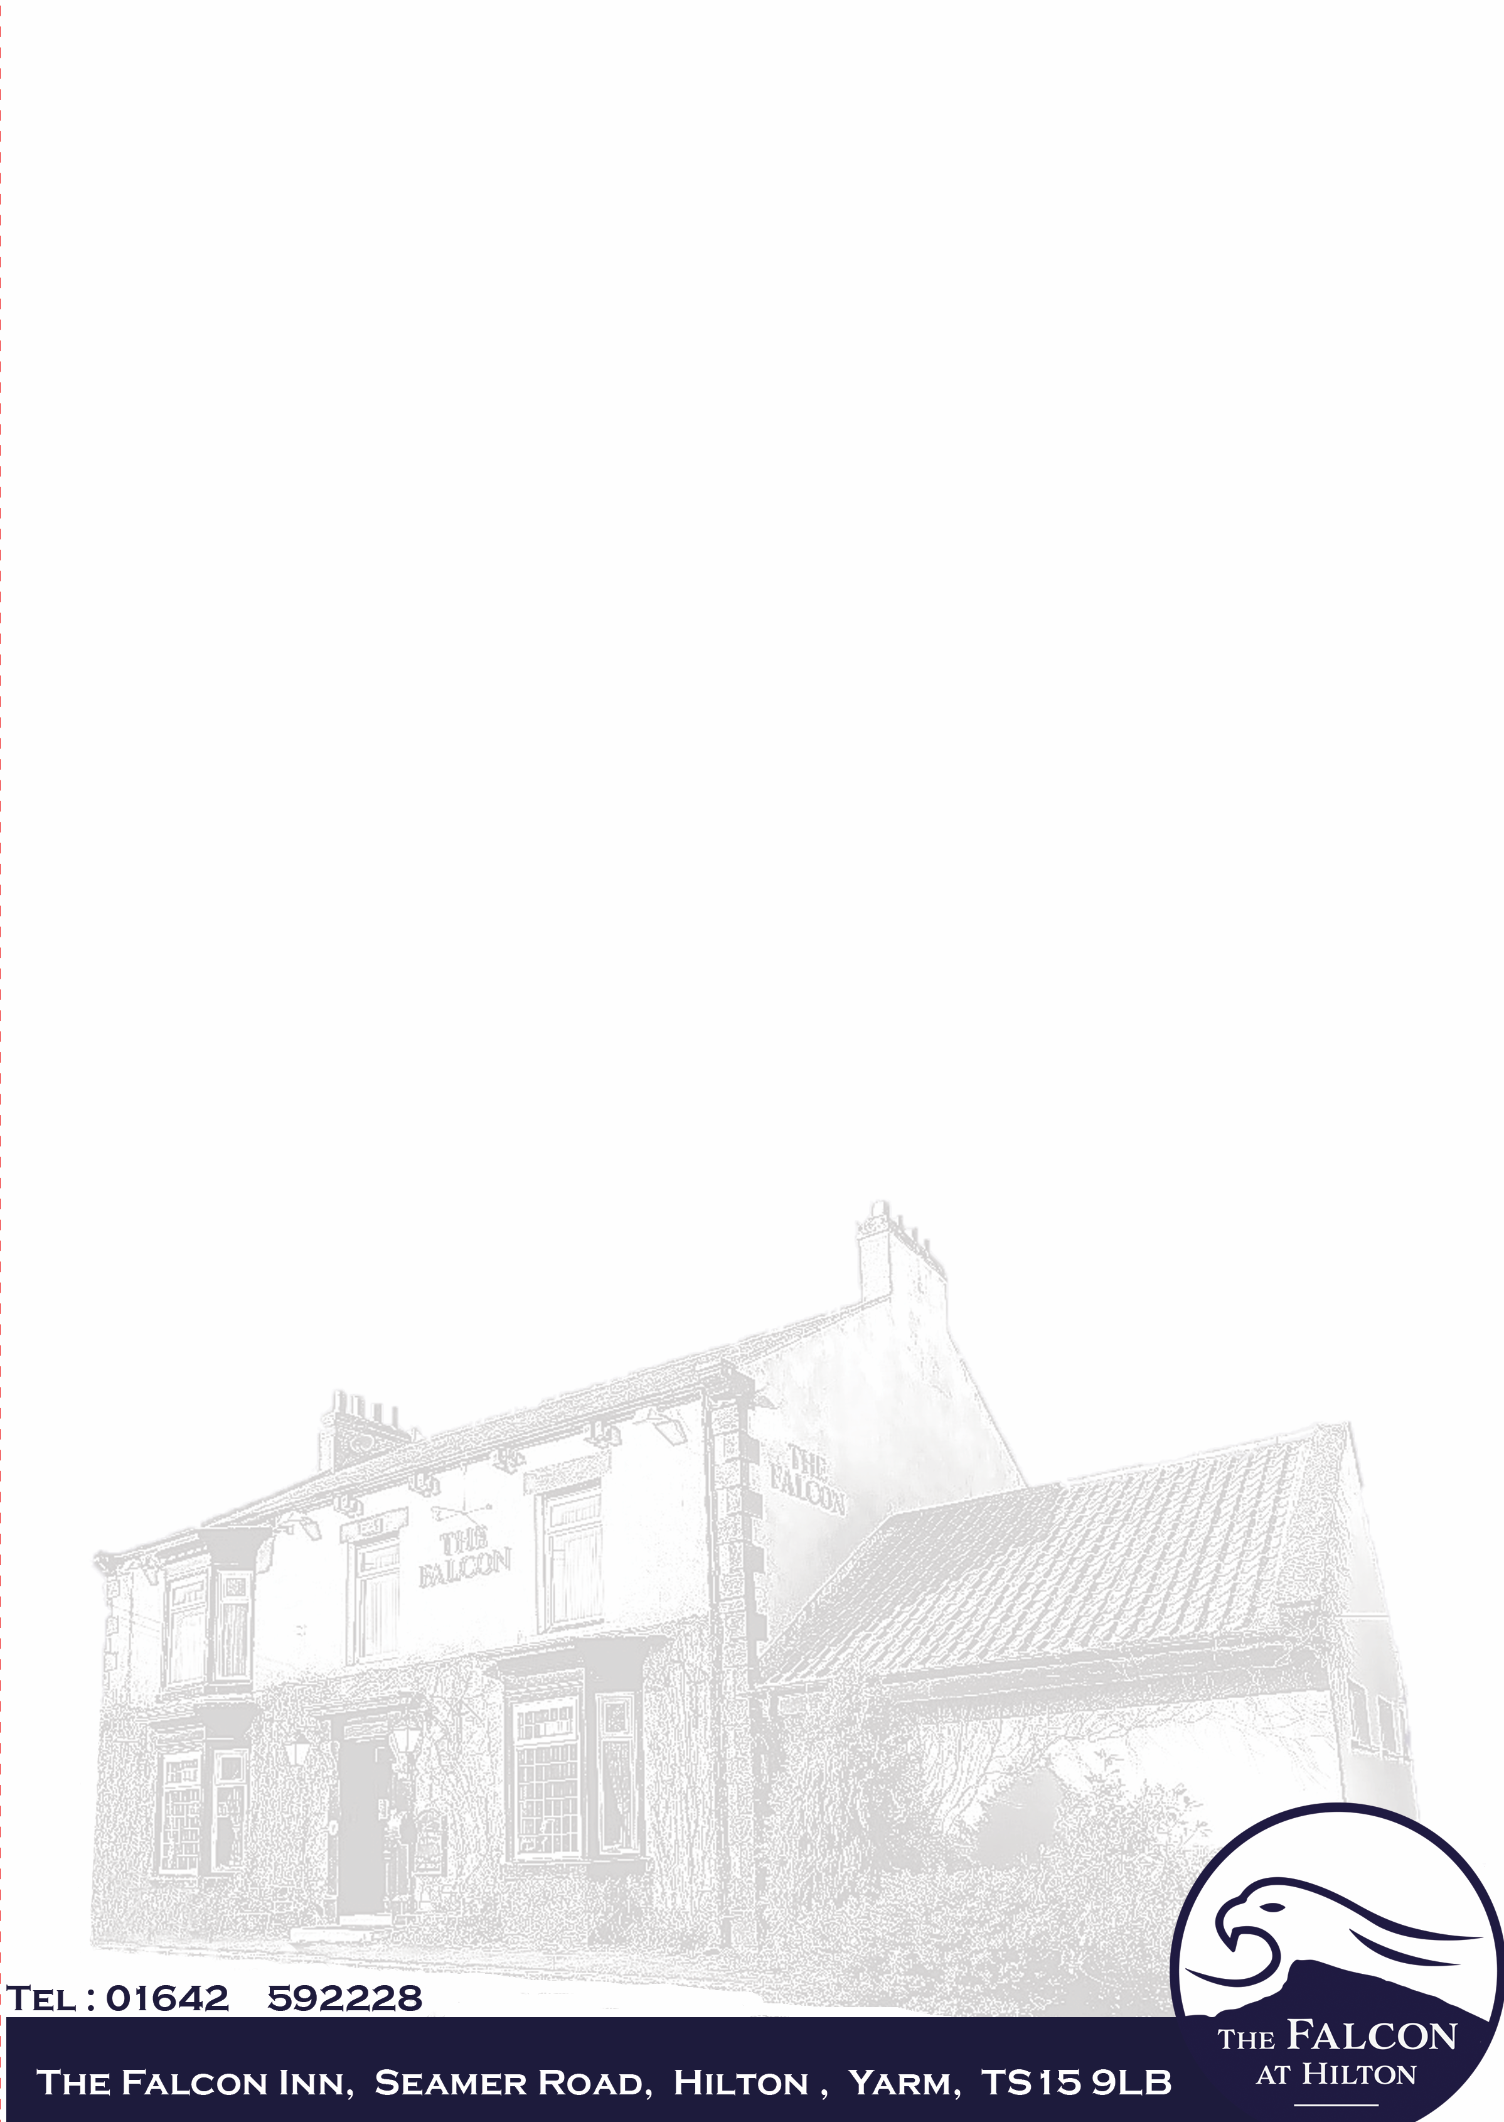  £20.95
Southern Fried Chicken Parmesan  Classic chicken parmesan with a twist. Southern fried chicken in herbs and spices. Accompanied with a Cajun sauce. Served with homemade chips and salad  Breakfast Parmesan  Classic chicken parmesan topped with Streaky bacon, black pudding, sausages and mushrooms with a side of beans. Accompanied with homemade chips. |  | £15.95  £15.95 | £20.95  £20.95

